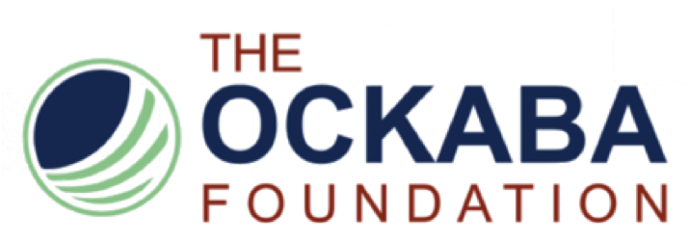

BAR EXAM STIPEND APPLICATION
Deadline: May 1, 2018

The OCKABA Foundation will award three (3) $1,500 stipends to three (3) eligible individuals looking to take the 2018 California bar examination. The stipends will be awarded to law students or recent law school graduates attending or graduated from law schools in Orange County only. First-time or subsequent bar exam takers are eligible. To be considered for a stipend, please submit this application with (1) a short personal statement demonstrating your commitment to community service; (2) your resume; and (3) a list of references. The ideal candidate should demonstrate a commitment to helping the Orange County Korean American community, and be active with the Orange County Korean American Bar Association. The award recipient must commit to volunteer at the pro bono clinics administered by the OCKABA Foundation (total of 6 visits, before and/or after the stipend is awarded). The stipends are expected to be awarded in November 2018.

Applicant Information
Name: |  |  |  | Date:
 | Last | First | M.I.

Address:
 | Street Address | Apartment/Unit #

 | City | State | ZIP Code

Phone: |  | Email
Law School Attended: |  | (Expected) Graduation Date:

Questions:
- Have you signed up for a future bar exam? ____
- If so, please provide the date of the exam(s) and for which state(s): ___________________________________________________________________________
- Have you taken any bar exam in the past? ____
- If so, please provide dates, for which state(s), and whether you passed: ___________________________________________________________________________
- Are you an active OCKABA member? ______
- Have you volunteered at pro bono legal clinics? ______
- If so, please provide dates, locations, and organizing organization(s). ___________________________________________________________________________

Please mail or email complete application to:
The OCKABA Foundation
P.O. Box 16991
Irvine, California 92623
ockabafoundation@gmail.com

